**Rehearsal Exercises MVC**

Before you start: to make sure that you can develop projects using ThymeLeaf, you must first try out the example project of the presentation.

So, then:

1. Download *example-mvc-2.zip*
2. Unzip and open in IntelliJ
3. Go to MainController. If ‘String’ is highlighted in red: adjust the SDK!
4. Run the project (top right )
5. Wait until you see this in the window at the bottom:
6. 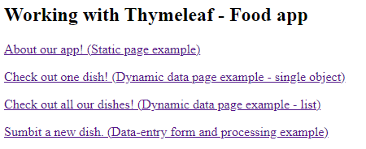Go to your browser and navigate to localhost:8080. You will need to see this homepage and then you can continue experimenting from there on.

**Exercise 1**

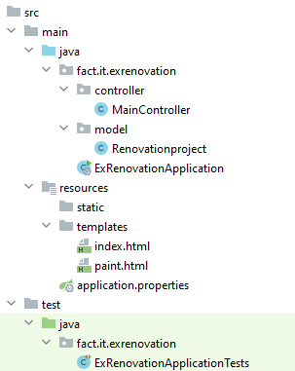

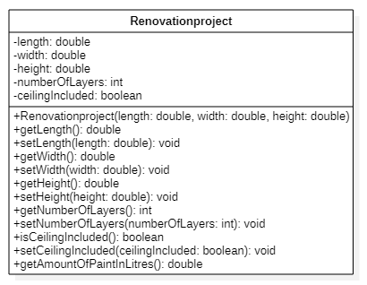Create a new project and add the class **Renovationproject** in a package called *model*according to the UML-diagram below:

The method *getAmountOfPaintInLitres*() indicates how many litres of paint you need.   
  
Tips:

* + area of all walls in the room = 2 * (length + width) * height
  + ceiling area = length * width
  + per 10m² you need one litre of paint

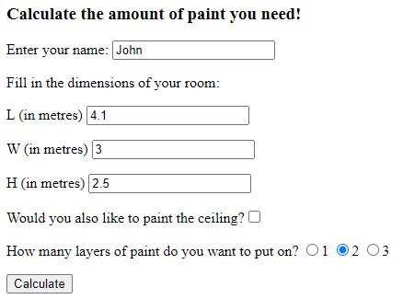Now create the web application. You start at **index.html** where you enter not only your name but also all the information needed to calculate how much paint you will need.

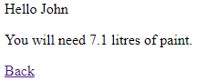  
If you enter this information you will (via the **MainController**) end up on the **paint.html** page where you can read how much paint you will need to buy.

The *Back* hyperlink takes you back to the homepage **index.html.**

Expand the exercise: when someone indicates that the ceiling also needs to be painted, an extra "good advice" is printed on paint.html:

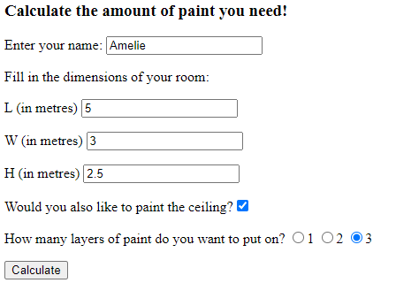

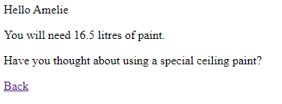

**Exercise 2**

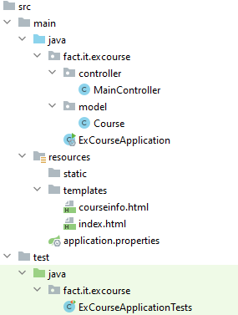Create a new project and add a **Course** class according to the UML-diagram below:

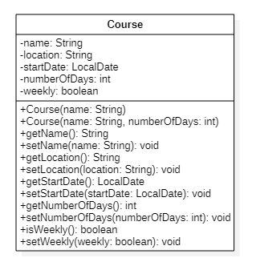

Now create the web application. Start with the page **index.html**:

1st example:

You should be able to fill in 4 text boxes and indicate whether the course is a weekly course, to then press the *Register a new course* button to submit the form.

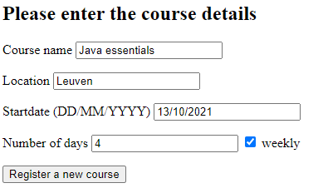

On **courseinfo.html** the following result should get displayed:

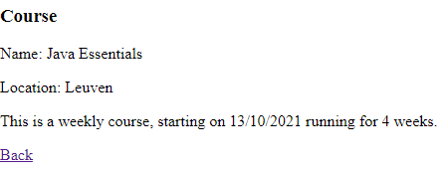

The *Back* hyperlink takes you back to the homepage **index.html.**

2nd example:

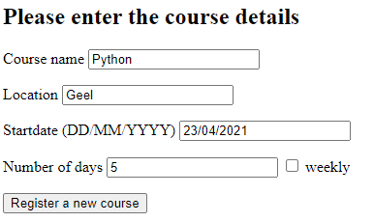

In this case the course runs for 5 consecutive working days.   
You should see the result in the **courseinfo.html** page**.**

